**GREEN CLOUD COMPUTING**

**Abstract**

Cloud computing is a dynamic and rapidly evolving field within information technologies, offering significant benefits such as scalability, reliability, and high performance at a relatively low cost. However, it also introduces new challenges for environmental protection. Green cloud computing seeks to address these challenges by transforming traditional cloud infrastructures into eco-friendly systems that improve energy efficiency, reduce carbon footprints, and minimize electronic waste (e-waste). This paper provides a comprehensive analysis of green cloud computing, covering key achievements and the current state of research. The discussion includes an overview of cloud computing, a summary of recent studies and technological advancements, and a focused exploration of the environmental issues associated with cloud computing. Additionally, this paper identifies future research directions and open challenges in the field of green cloud computing. By integrating environmental considerations into cloud technologies, green cloud computing holds the promise of significant environmental protection, alongside its economic and technological advantages.

**Introduction**

Over the past decade, cloud computing has become a dominant platform for businesses, enabling organizations to focus on core operations without the burden of managing complex IT infrastructure. According to the National Institute of Standards and Technology (NIST) (Mell & Grance, 2011), cloud computing provides various service models—Infrastructure as a Service (IaaS), Platform as a Service (PaaS), and Software as a Service (SaaS)—that have significantly attracted business application owners to migrate to the cloud. Cloud-based data centers, platforms, and servers offer the elasticity needed to meet the sudden demand for resources, making them ideal for both multinational corporations and small-scale enterprises (Heininger, 2012).

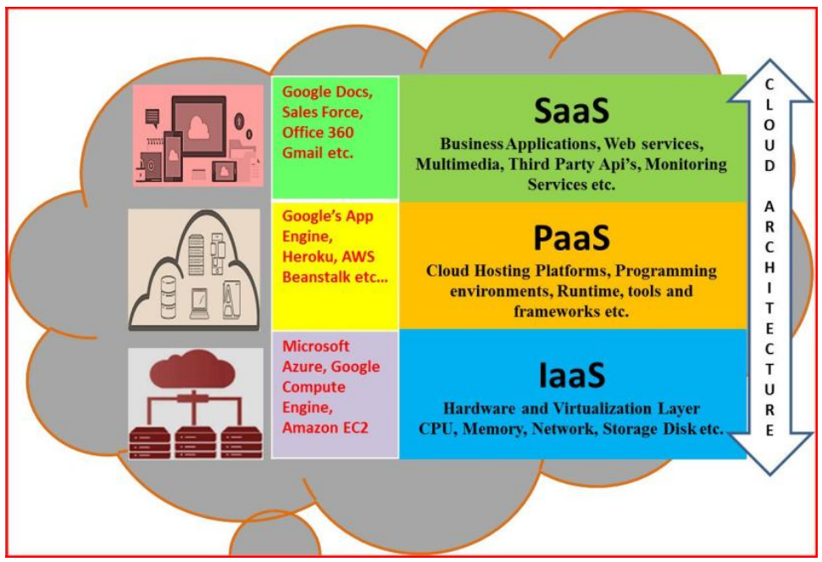

The widespread adoption of cloud services is evident in the integration of everyday devices such as smartphones, tablets, smartwatches, healthcare devices, and sensors, all of which rely on cloud storage for data management. Major software applications, including emails, messaging services, enterprise apps, social networks, e-commerce platforms, and streaming services, leverage cloud computing for data storage, processing, sharing, and security. Notably, Google hosts all of its services—Gmail, Google Drive, YouTube, and more—on its proprietary cloud platform, providing high-quality services to a global user base. According to a 2018 Forbes report, the global public cloud revenue was valued at $175.8 billion, with a forecasted increase to $206.2 billion in 2019, reflecting the rapid growth and widespread utilization of cloud services.

While the elasticity and efficiency of cloud services are meeting the demands of consumers, service providers are grappling with significant challenges, particularly the enormous power consumption of data centers. This leads to higher operational costs, increased carbon emissions, and reduced profitability. Despite addressing many organizational challenges, traditional cloud computing systems face several limitations, including high energy consumption, CPU idle times, the need to deploy resources at maximum capacity, carbon emissions, and the production of electronic waste (e-waste). These issues underscore the urgent need to evolve current cloud environments into more sustainable, eco-friendly models—what is now referred to as Green Cloud Computing.

Green Cloud Computing represents a novel shift in the cloud computing paradigm, with the primary goal of transforming cloud environments to be more environmentally sustainable. This includes reducing the ecological impact through energy-efficient power management, resource virtualization, multi-tenancy, consolidation, and other green practices (Hilty & Arnfalk, 2006). The overarching objective is to ensure that the growth of cloud computing does not come at the expense of environmental health.

However, creating a truly green cloud environment involves more than just adopting energy-efficient technologies. It requires a holistic approach that considers both the direct and indirect environmental impacts of cloud operations. For example, a cloud service provider may adhere to strict energy-saving policies but still rely on coal-based power, thereby indirectly harming the environment. Thus, Green Cloud Computing policies and standards must be designed with a comprehensive view of the cloud's ecological footprint. In addition to these policies, the development of monitoring tools and technologies is essential for building a sustainable cloud architecture.

This paper explores the architecture and components of Green Cloud Computing, focusing on the integration of tools like scalable process schedulers, custom job scheduling algorithms, and resource calculators. It also discusses the role of Green Cloud Providers (GCP) in monitoring and certifying cloud services as green. By providing an in-depth analysis of the technologies, policies, and strategies involved in Green Cloud Computing, this paper aims to highlight the significance of adopting sustainable practices in cloud services and to offer insights into future research directions for achieving a greener ICT ecosystem.

**Overview/Background of Cloud Computing**

Cloud computing has emerged as a pivotal paradigm in modern information and communication technologies (ICTs), offering dynamic, high-capacity computing capabilities without the need for additional on-premises resources. This flexibility is made possible through cloud data centers that utilize virtualization technologies, allowing organizations to reduce costs by minimizing investments in hardware and software.

Cloud computing integrates several foundational technologies, such as Service-Oriented Architecture (SOA), virtualization, and more recent innovations like grid computing and containerization. These technologies have evolved rapidly, leading to highly adaptable and scalable cloud solutions. According to NIST, cloud computing provides "ubiquitous, convenient, on-demand network access to a shared pool of configurable computing resources" that can be quickly provisioned and released with minimal management effort (Mell & Grance, 2011).

The primary service models—Infrastructure as a Service (IaaS), Platform as a Service (PaaS), and Software as a Service (SaaS)—cater to different user needs, from independent software vendors and developers to end-users. Cloud computing can be deployed in various models: private, public, hybrid, and community clouds, each offering different levels of security and scalability.

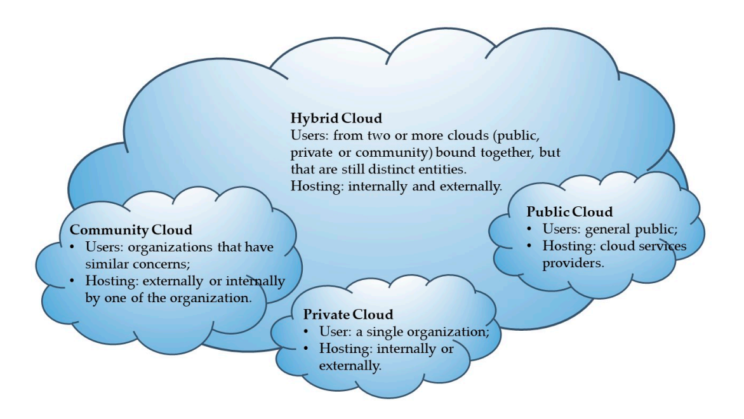

From an environmental perspective, cloud computing can enhance energy efficiency and reduce e-waste through centralized processing and resource sharing. SaaS and PaaS providers contribute to these efforts by optimizing software-level energy consumption and implementing green practices within data centers. However, transitioning to cloud computing also presents challenges, such as the need for architectural changes, data transfer obstacles, and security concerns.

while cloud computing offers significant benefits, including cost savings, scalability, and environmental advantages, addressing its challenges is essential to fully realize its potential as a sustainable and efficient technology for the future.

**Key Components of Green Cloud Computing**

Green cloud computing aims to reduce the environmental impact of cloud services by integrating eco-friendly practices into cloud infrastructure. The following are key components essential to achieving a sustainable cloud computing environment:

**1. Energy-Efficient Data Centers**

Data centers are at the heart of cloud computing, but they are also among the largest consumers of electricity. To mitigate their environmental impact, energy-efficient data centers are designed with advanced technologies and practices that minimize power consumption while maintaining high performance. These include:

Efficient Cooling Systems: Traditional air conditioning systems are being replaced by innovative cooling methods such as liquid cooling, free cooling (using external cool air), and hot/cold aisle containment to reduce energy use.

High-Efficiency Power Supplies: Data centers are adopting power supplies with higher efficiency ratings (e.g., 80 PLUS certification) to reduce energy waste.

Server Virtualization: By running multiple virtual machines on a single physical server, data centers can maximize resource utilization, reduce the number of physical servers required, and consequently lower energy consumption.

**2. Renewable Energy Integration**

Integrating renewable energy sources is a crucial step in reducing the carbon footprint of cloud computing. Cloud service providers are increasingly turning to renewable energy—such as solar, wind, and hydroelectric power—to meet their energy needs. Key strategies include:

On-Site Renewable Energy Generation: Data centers are being equipped with solar panels, wind turbines, and other renewable energy systems to generate power on-site, reducing reliance on fossil fuels.

Power Purchase Agreements (PPAs): Some cloud providers enter into PPAs with renewable energy suppliers, ensuring that a significant portion of their energy consumption is sourced from renewable resources.

Energy Storage Solutions: To address the intermittent nature of renewable energy, cloud providers are investing in advanced energy storage technologies like batteries to store excess energy generated during peak production times for use when renewable energy generation is low.

**3. Resource Management**

Effective resource management is essential for minimizing energy use and maximizing the efficiency of cloud computing environments. This involves:

Dynamic Resource Allocation: By dynamically allocating resources based on real-time demand, cloud systems can avoid over-provisioning, reducing energy waste and improving efficiency.

Load Balancing: Load balancing distributes workloads evenly across servers, preventing any single server from becoming overloaded or underutilized. This not only improves performance but also reduces the energy required to manage fluctuating workloads.

Auto-Scaling: Auto-scaling mechanisms adjust the number of active servers automatically in response to changes in demand, ensuring that resources are only used when necessary.

**4. Carbon Footprint Reduction**

Reducing the carbon footprint of cloud computing is a primary goal of green cloud initiatives. Strategies for achieving this include:

Carbon Offsetting: Some cloud providers invest in carbon offset programs, such as reforestation projects or carbon capture technologies, to compensate for the emissions generated by their operations.

Energy-Efficient Software Development: Developing software that is optimized for energy efficiency can significantly reduce the energy consumption of cloud-based applications. This includes minimizing computational complexity, optimizing code to run more efficiently, and reducing unnecessary data processing.

E-Waste Management: Proper management and recycling of electronic waste (e-waste) generated by outdated or retired cloud infrastructure components are critical for minimizing the environmental impact of cloud services. This includes refurbishing and reusing hardware, as well as partnering with certified e-waste recycling companies.

**Case Studies**

**Google Cloud**

Google Cloud has been at the forefront of implementing green cloud computing practices, driven by the company's overarching goal to operate the cleanest cloud in the industry. One of Google Cloud's key strategies is the integration of renewable energy into its operations. Google has been carbon-neutral since 2007 and aims to run entirely on carbon-free energy by 2030. This ambitious goal is supported by the extensive use of solar and wind energy to power its data centers. In addition, Google has invested in AI-driven solutions that optimize energy use within its data centers, enhancing efficiency while reducing environmental impact.

For example, Google's DeepMind AI has been instrumental in reducing the energy needed for cooling by up to 40%, significantly lowering the overall power consumption of its data centers. The company also uses carbon offsetting programs to neutralize any remaining emissions, ensuring that its operations contribute minimally to global carbon footprints. Furthermore, Google Cloud has introduced various tools and services that help customers monitor and reduce their carbon impact, further extending the benefits of green cloud computing beyond its own operations ([Google Cloud Sustainability, 2021](https://cloud.google.com/sustainability)).

**Amazon Web Services (AWS)**

Amazon Web Services (AWS) is another major player in the cloud computing industry that has made significant strides towards sustainability. AWS has committed to achieving 100% renewable energy usage for its global infrastructure by 2025, as part of Amazon's broader Climate Pledge to reach net-zero carbon by 2040. To support this, AWS has been investing heavily in renewable energy projects, including solar and wind farms, which contribute directly to the power used by its data centers.

AWS also emphasizes energy efficiency in its data centers through continuous innovation in server design, cooling, and power management. For instance, AWS has developed custom-built servers that are optimized for energy efficiency, reducing the energy needed per workload. Additionally, AWS offers its customers tools like the AWS Carbon Footprint Tool, which helps businesses track and reduce their carbon emissions by optimizing their cloud usage. These efforts not only demonstrate AWS’s commitment to sustainability but also provide a framework for other organizations to follow in reducing their environmental impact ([AWS Sustainability, 2021](https://aws.amazon.com/sustainability/)).

**Challenges and Future Trends**

Green Cloud Future Challenges

Energy Efficiency: As today clouds are designed with the multi-core CPUs, there is a need of designing the power optimization and management techniques to support the power management with multi-core CPUs. Another huge power consuming part of the cloud is the data center, which is a collection of data storage components and data management software. An efficient power consumption monitoring system, dynamic power management system and intelligent power supply decision making systems are the research challenges in this area. By considering the current pace of IT, we need a comprehensive and intelligent mechanism to tackle the entire cloud architecture level energy optimization issues.

Virtualization: Many former researches were widely concentrated on designing the efficient cloud virtualization process, but the virtualization is still suffering from some high-end optimization relevant limitations. Designing novel methodologies with the state-of-the-art technologies to optimize the entire lifecycle of the virtualization process is an important research challenge. Automated optimal VM’s creation with substantial resources and dynamic resource allocation & sharing facilities without affecting the cloud performance are the other considerable research challenges in virtualization. MultiTenancy: Although this an essential character of green cloud, at present multi tenancy is suffering from the privacy and security concerns. Designing the

secured multi-tenant architectures and privacy-preserved secured access to multi-tenant modules are the considerable future research challenges.

Consolidation: Design of intelligence support in VM’s consolidation, Multi aspect based threshold value calculation, leveraging the key resources and server downtime management became the future research challenges in this area.

Eco-Friendliness: This area mainly concentrates on environment based tools design i.e. carbon emission calculator tools to measure the effect of the cloud on nature. Need to design a comprehensive framework to certify the clouds with ranking, based on multiple aspects of Green Cloud Computing.

**Future trends**

As the global ICT industry continues to grow, so does the need for sustainable cloud computing solutions. The future of green cloud computing will likely focus on several key areas to address the increasing environmental concerns associated with data centers and cloud infrastructures. One significant trend is the development of **next-generation green data centers**. These data centers will go beyond simply improving energy efficiency by incorporating holistic environmental strategies, including advanced cooling systems, renewable energy integration, and sustainable building designs. The focus will be on minimizing CO2 emissions, reducing electronic waste (e-waste), and optimizing the consumption of natural resources such as water and electricity.

Another emerging trend is the **advancement of algorithms and frameworks** that optimize resource allocation in real-time, further reducing the energy footprint of cloud operations. These algorithms will leverage artificial intelligence (AI) and machine learning (ML) to predict demand and dynamically allocate resources, ensuring that only the necessary computing power is used at any given time. This approach not only reduces operational costs but also significantly decreases the overall carbon footprint.

Moreover, there will be an increased emphasis on **sustainability metrics and reporting**. Cloud service providers will likely adopt standardized frameworks to measure and report their environmental impact, including energy consumption, carbon emissions, and e-waste generation. These metrics will not only help providers track their progress toward sustainability goals but also allow customers to make informed decisions based on the environmental performance of cloud services.

The integration of **circular economy principles** into cloud computing is another promising trend. This involves designing cloud infrastructures and devices with recyclability and reusability in mind, thereby extending the life cycle of hardware and reducing waste. Additionally, green cloud computing is expected to increasingly align with global sustainability initiatives, such as the United Nations' Sustainable Development Goals (SDGs), particularly those focused on climate action and responsible consumption.

Finally, **regulatory and policy developments** will play a critical role in shaping the future of green cloud computing. Governments and international bodies may introduce stricter regulations on energy use and emissions for data centers, pushing the industry toward greener practices. As the demand for cloud services continues to rise, these future trends will be pivotal in ensuring that the growth of cloud computing contributes positively to environmental sustainability.

**Conclusion**

**References**

[Energy efficient computing- Green cloud computing](https://ieeexplore.ieee.org/abstract/document/6533519)

Publisher: IEEE

Authors: Anubha Jain, Manoj Mishra, Sateesh Kumar Peddoju, Nitin Jain

[Green Cloud Computing: A Literature Survey](https://www.mdpi.com/2073-8994/9/12/295)

Author: Laura-Diana RaduORCID

Faculty of Economics and Business Administration, Alexandru Ioan Cuza University of Iasi, Romania.

[An Analysis Report on Green Cloud Computing Current Trends and Future Research Challenges](https://drive.google.com/file/d/1R_bxjSCO7auxRPLHi1yr6Nkblv7cm_hF/view?usp=drive_link)

Authors: Archana Patil, Rekha Patil

Visvesvaraya Technological University(VTU), Karnataka, India.

PDA College of Engineering, Karnataka, India.